Module 2 Labs

COMPSCI 115- Python Programming

***Instructions:***

* ***All your answers should be saved in this word document***
* ***Your code for each question should be included in this document.***
* ***Upload the python file to BOLT***
* ***Test your code and take a screenshot of the output***

1. You have been given an arithmetic expression and need to turn it into a Python expression.

Rewrite the equation shown in *Figure 2.4* as a Python expression and get the result of the equation: Pay special attention to the order of operations.

Print(3*(9-2))

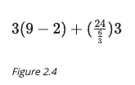

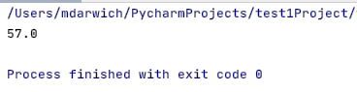

1. You are given the number of days that you have been driving, and you will write a Python script to work out the equivalent number of years and weeks.

Write a script that takes user input as days and converts the days into years, weeks, and days, and then prints them out. We can ignore leap years.

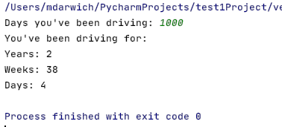

1. You will create a Python script that will take a user's input and convert lower case letters in the string into upper case letters depending on the user input.

Write a script that converts the count amount of letters starting from the end of a given word to uppercase. The script should take the word as a string and specify the count amount of letters to convert as an integer input from the user. You can assume that the count variable will be a positive number.

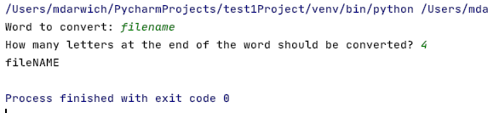

1. You want to write a Python script that takes a string and counts the occurrence of a specified word.

Write a script that counts and displays the number of occurrences of a specified word in a given excerpt. The script should request two input values from the user, that is, the excerpt and the word to search for. You can assume that the word will not occur as a substring in other words.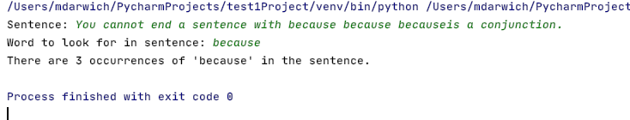

Output:

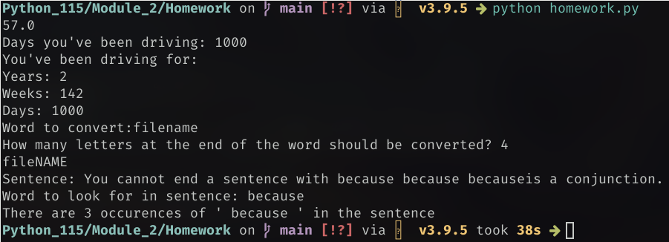Solutions:

attached homework.py